Name:_________________________

**Using the Push Buttons with LEDs - MakeCode**

**What you need:**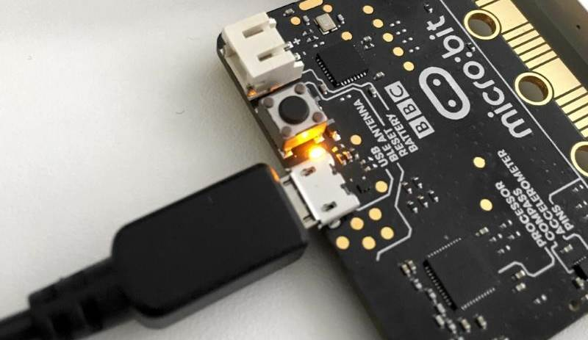

1. A computer with a USB port
2. V2.0 micro:bit
3. USB cable

**Setup:**

1. Plug in your micro:bit with the USB cable. The small USB mircoB end goes to the micro:bit and the regular USB end goes to the computer.
2. In a browser, go to <https://makecode.microbit.org/>. This is where you will program your micro:bit.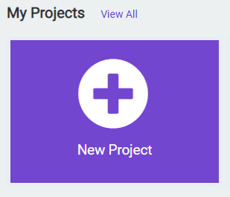
3. Click on ‘New Project’
4. You can name your project whatever you want, but you should name it based on the title of the lab. In this case, ‘Push Buttons and LEDs’

**Instructions:**

1. Inside the **forever** code block, we will use the two **if** blocks from the **Logic** tab. This code block will execute whatever code is inside it when the statement we give it becomes true.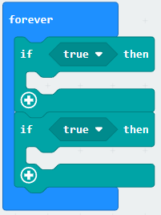

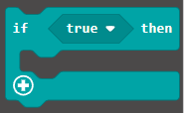

1. Inside the **if** code block, we need to change the condition of when the if statement becomes true. We will change it to when the micro:bit detects when button A or B are pressed. Drag the **button pressed** logic block from the **Input** tab, inside of the **if** code block where it currently says **true.** Repeat for the other button and change the drop down to say button **B.**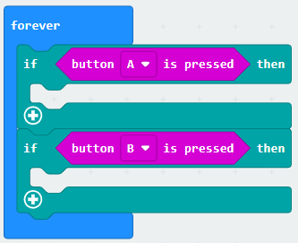



1. To have the micro:bit turn on the led with one button and shut them off with the other button, we need to place both a **show icon** and **clear screen** code block from the **Basic** tab, like the one we used in the beginner projects. Drag the show icon code block into the first **if** code block that is for button **A.** Drag the clear screen code block in the second if code block for button **B.**

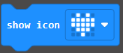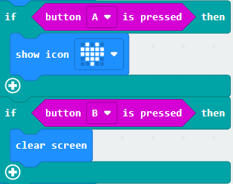

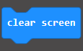

1. Click the **Download** button on the bottom on the bottom left hand side of the screen. This will upload your program to the micro:bit. When you press button **A**, does the screen display an image? Then press button **B.** Does the image go away?

**You Try It!**

Can you change what image the screen displays?